**STAT 112 - Introduction to Data Processing and Visualization Project**

Project 1 by:

ZARNAB TARIQ KAHN

2704187

ABSTRACT:

This research is a global automotive sales relationship with multiple factors and we use Tableau to explain these trends by data visualization and analysis. This research will answer specific questions connecting different quantities from two separate data sets and explaining the relationships between them and joining them by a union.

INTRODUCTION:

Global trends and their correlation with automobile industry is the main goal of this research. We dive deeper into the two data sets and find how different qualities of a country effect the automotive industry and sales. The variables that I have used are as follows:

|  |  |  |
| --- | --- | --- |
| Variable name | Description | Scale |
| Country | Name of country | nominal |
| Automotive sales | Total sales amount | ratio |
| GDP | Gross domestic product | interval |
| Population | Total population of a country | ratio |
| Gasoline prices | Price of gasoline per litre | ratio |
| CO2 emissions | Carbon dioxide emission in tons | ratio |
| Price of automobile | Price of each item | ratio |
| Quantity ordered | Number of items ordered | interval |
| Tax revenue | Tax revenue as a percentage of GDP | ratio |

We will achieve several insights about the data and answer our research questions through in-depth exploration of the visualizations we make on Tableau platform.

# EXPLORATORY DATA ANALYSIS:

In this Project, we conducted 6 questions and explained each one in detail with relevant visualization.

* **Is there a significant correlation between GDP and automobile sales?**

The mosaic plot is the most appropriate way to show the relationship between a country's GDP and automobile sales. GDP reflects a nation's wealth, and the higher the GDP, the greater the likelihood that people can afford cars. As observed by the plot, the size of the square represents the GDP, while the color intensity represents the car sales. We can interpret that the USA, being the largest and most densely colored, has a strong positive correlation between GDP and car sales, indicating it as a wealthy nation. In contrast, smaller GDP nations like Finland have smaller portions on the graph and relatively low car sales, again showing a direct relationship between the two. The results are clear, however, some deviations can be seen, which may occur due to the availability of public transport and personal preferences.

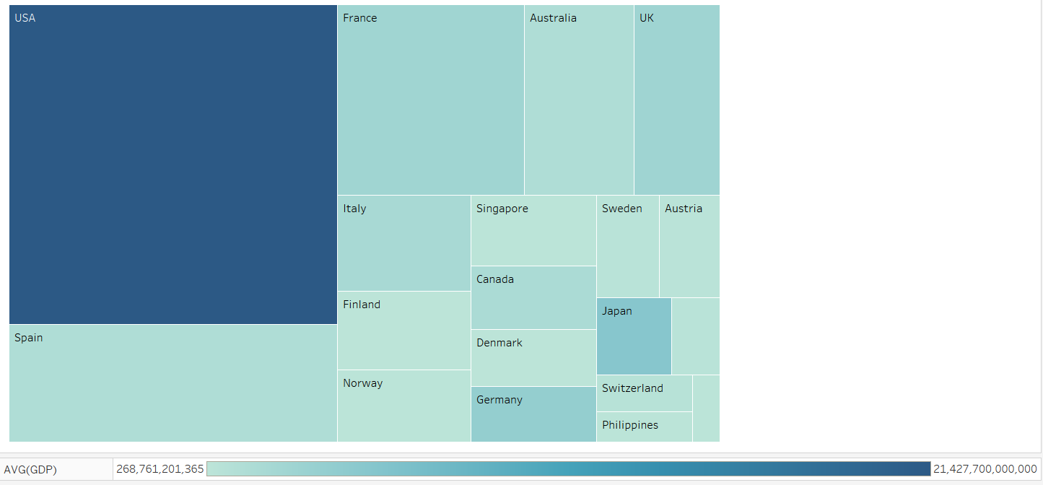

* **How do trends in gasoline prices compare to the trends in automobile sales?**

The best way to show the trend of gasoline price against automobile sales effectively overtime is a dual axis line chart. It is observed that high gasoline consumption is equal to high vehicle ownership, thus countries with higher gasoline consumption often have a higher vehicle ownership leading to more automobile sales. We can describe this trend as a direct relationship. As seen in the graph, both Gasoline prices and automobile sales increase linearly from 2018-2019 till they reach a maximum However, after 2019 gasoline prices and automobile sales fall is slightly differently which indicates that other external factors such as economic or social conditions might have an effect on the sales to decrease as well which outweighs the influence of gasoline price.

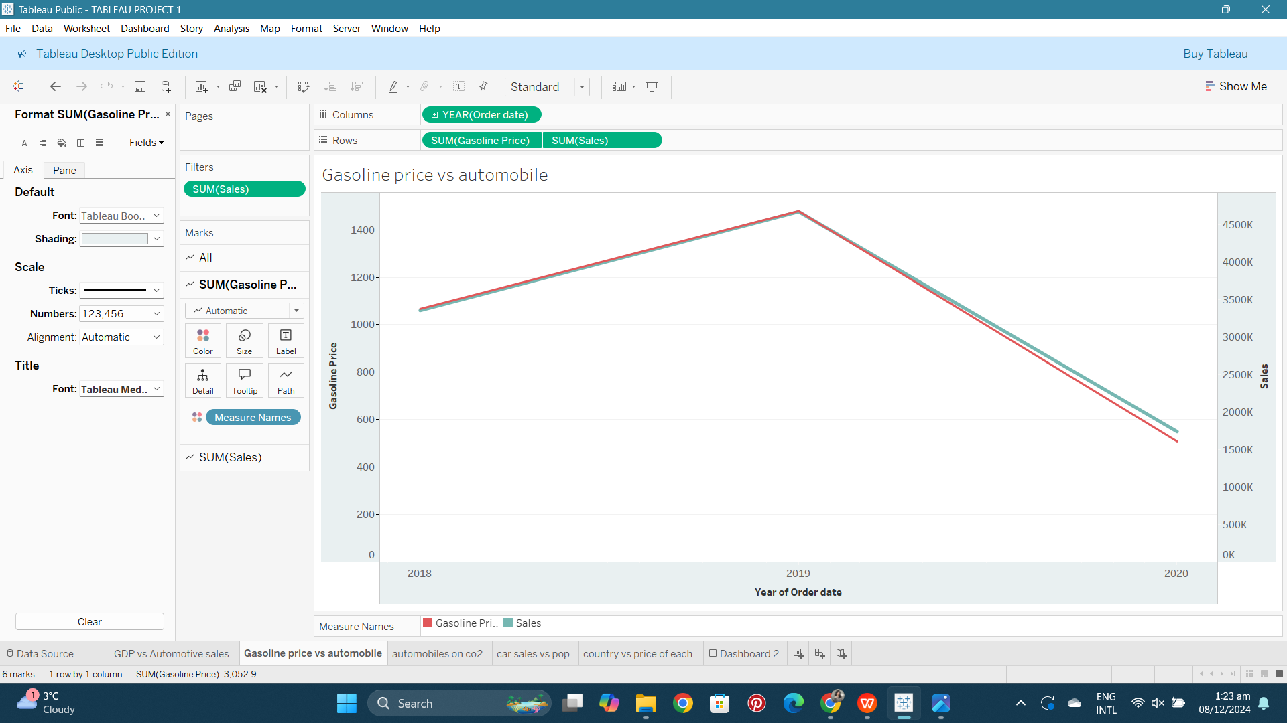

* **Whats the effect of automobiles ordered on the CO2 emissions?**

.A higher volume of gasoline-powered vehicles correlates with increased CO2 emissions, as these vehicles rely on fossil fuels. An observation that there is a positive correlation between number of automobiles ordered and CO2 emissions in a country can be made. Cars are one of the main causes of pollution as they cause huge CO2 emissions on a daily basis. We can see a positive relationship in countries for example UK or France as the scatter plot shows higher number of automobiles tend to have higher CO2 emissions. It can also be seen that some countries may not follow the trend for example Spain having the highest number of automobiles sales still manages to have lower CO2 emissions which means there are external factors effecting the relationship such as electric or hybrid cars which highly reduce the CO2 emissions. These factors along with public transportation systems and government policies can maintain low CO2 emissions to the environment. Even though there is a positive correlation, countries with advance vehicle technologies are better at tackling the CO2 emission issues despite having higher automobile orders.

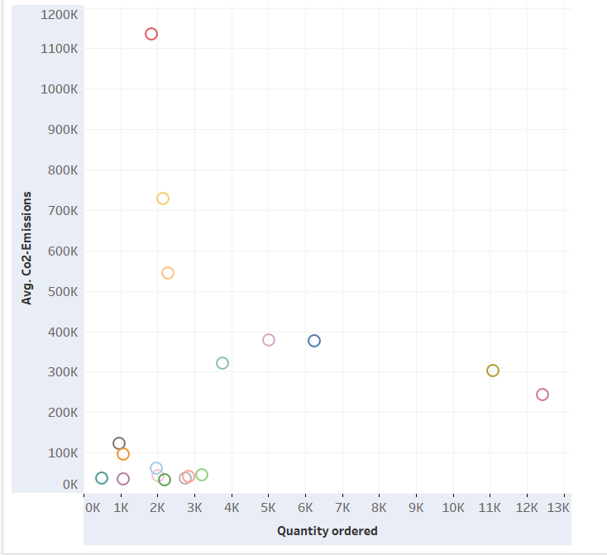 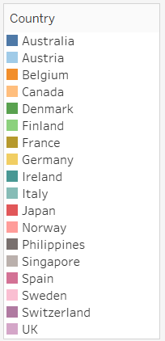

* **How does population influence car ownership across countries?**

Large populations often have higher car sales as there can be more potential consumers, but as we can see, that is not always correct in some cases as many other factors play a role in car sales, such as public transport systems, cultural factors, and geographical area. We chose to display this information on a bubble chart where the size of the bubble represents the population, the color intensity represents the car sales, and the country's name is labeled on each circle, making the graph easily understandable. It can be analyzed that large population countries, for example, the USA, have moderate car sales mainly due to the greater reliance on public transport transport systems or limited parking spaces . Moderate population countries such as France, the UK, or Italy have moderate car sales, and they show a balance. Furthermore, small population countries such as Norway also have moderate car sales. This is due to many economic factors such as the lack of public transport or low-income rates. The overall influence is that these two are directly proportional, but additional factors influence the trend, making it multifaceted.

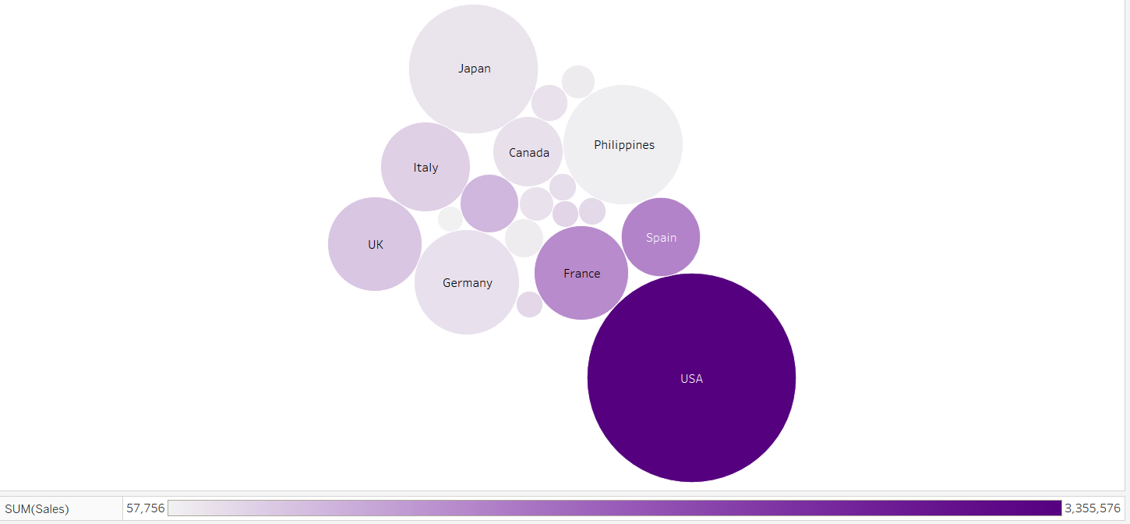

* **How does price of automobiles vary across different countries?**

For this question a Bar chart is used to display the relation of countries(x-axis) vs. average automobile prices(y-axis) as it shows a straightforward and clear comparison between countries and the color gradient indicates the tax revenue percentage of each country. According to the graph, there is a positive relationship between a country's tax revenue generation and its total automobile price. The USA, having the highest peak, indicates the total price for automobile sales, suggesting a large market size of demand for vehicles. In comparison, countries like Spain and Australia have moderate total prices, while Philippines and Ireland shows lowest, suggesting affordability constraints. As other countries are more evenly distributed, the USA stands out as a clear outlier in this trend.

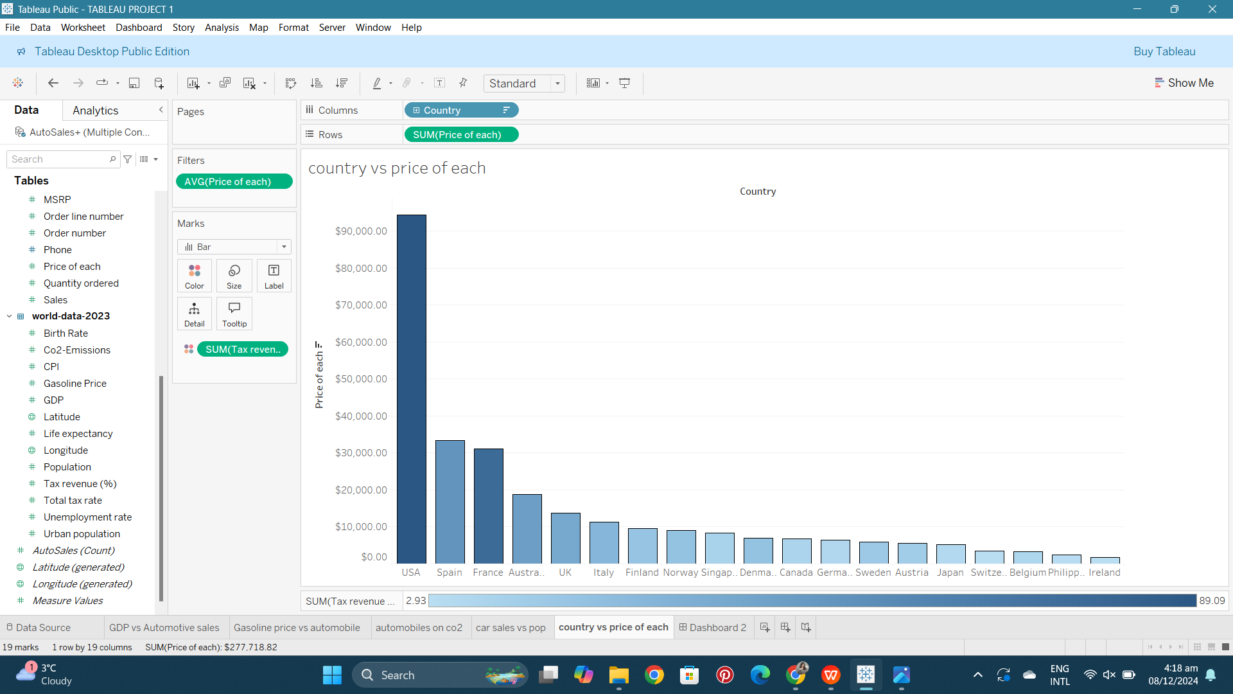

CONCLUSION:

I have discovered multiple socioeconomic trends that effect the sales of automobiles through my thorough research analysis. We discovered that GDP of a country plays a very important role in determining their citizens capability to afford automobile sales. Generally a country with higher GDP has higher automobile sales and vise versa. Some other trends effecting the visualizations is public transport systems of the countries. We noticed USA taking over every graph as being the top one in GDP, in car sales and mostly in every variable by such a steep hike that it can be said USA is an outlier. We believe these findings can help the automotive countries in the future to target their beneficial market and maximize sales by making strategies and planning based on these trends

<https://public.tableau.com/app/profile/zarnab.tariq.khan/viz/TABLEAUPROJECT1_17336543590480/Dashboard2?publish=yes>